Some Questions that will make clear about the requirements of the vendor machine:

|  |  |
| --- | --- |
| Question | Answers should be provided |
| Which public transport will be integrated the automated ticket-issuing system? | Is that bus, train, plane or anything else? |
| Which payment method will be provided in the machine? | Cash, Banking, Credit card, QR code payment? |
| What steps do users have to take to purchase ticket? | Choose destination, number of tickets or payment method and they have to wait for issuing ticket? |
| What will be occurred if users don't have enough money to pay for the ticket? | Will error message be illustrated or the system will warn the users for that? |

|  |  |
| --- | --- |
| When Users Purchase tickets | Solution should be provided |
| What do the vendor machine do to protect the users information? | Use any solution to secure customers information? |
| If the payment method integrates the other payment system as Momo, VnMart, ipay… how will the payment take place? | Is there the interaction between Vendor Machine and the other payment system? |
| Will the services provide for the customers? | The system should provide the hotline or staff to suport the customers? |

Model describes Use case Diagram of Vendor Machine

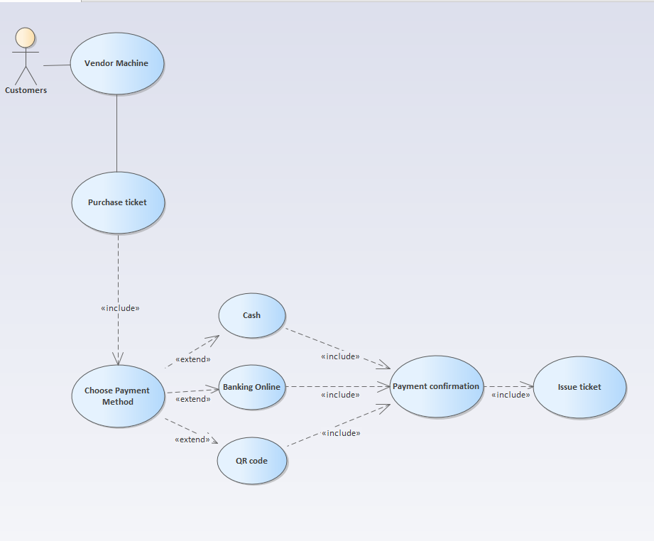

Sequence diagram:

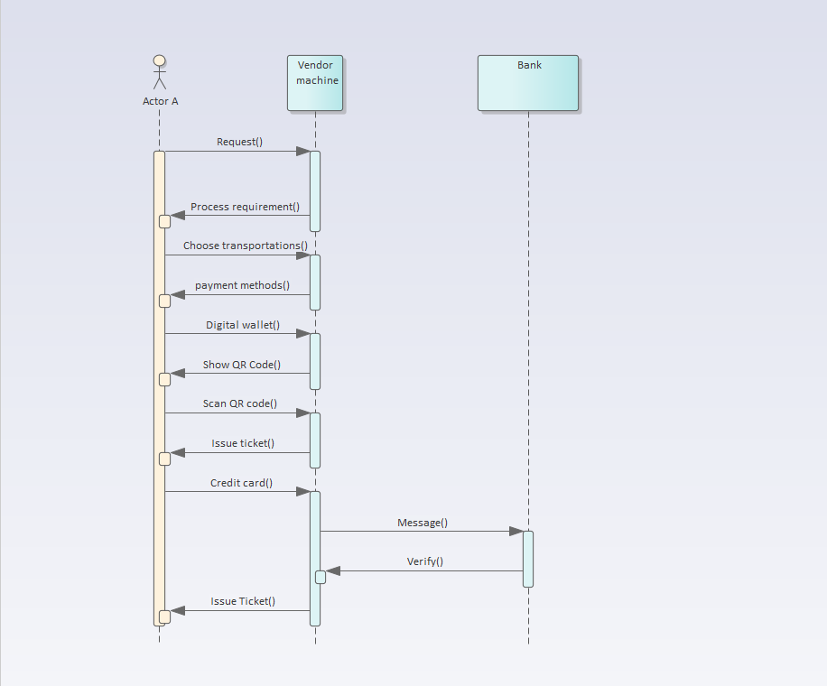

Balsamiq describes activities of Vendor machine:

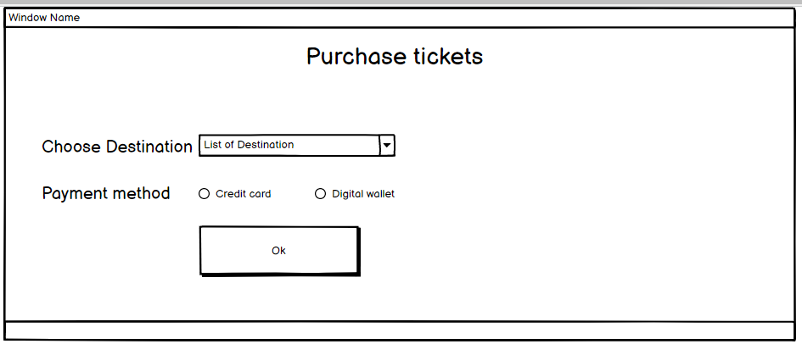

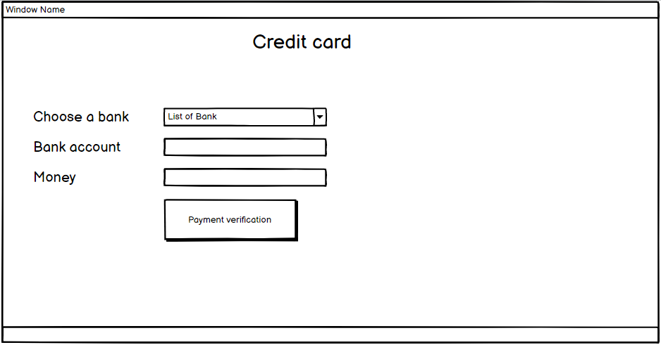

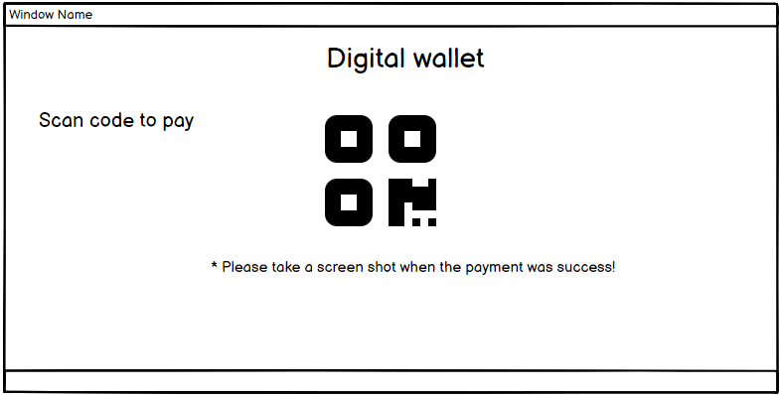

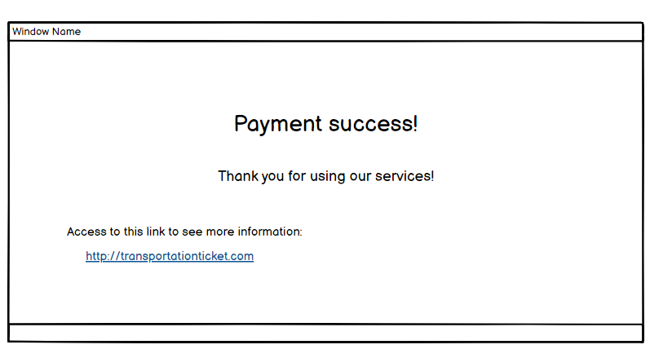

Class Diagram:

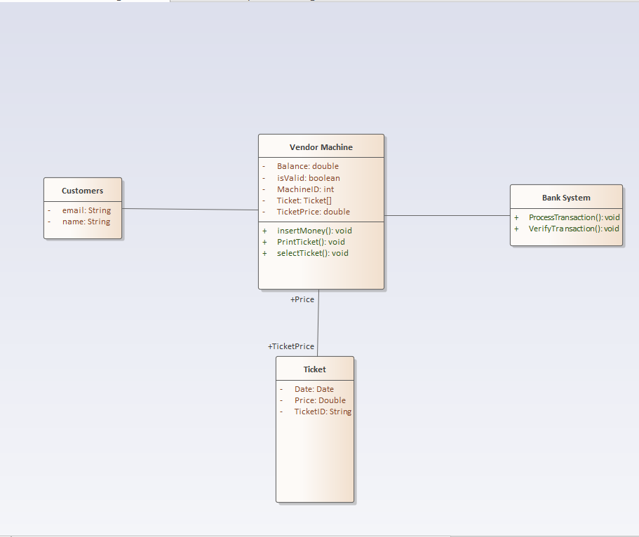

I). Functional requirements of the Vendor Machine:

- Show list of destination.

- Allow users to choose payment methods.

- Issue ticket after payment.

- Update the status of route.

II). Non-Functional Requirements:

- Reliable: the system need to protect the user information and prevent faking ticket.

- Respond: the system of the vendor machine need to respond to the user quickly, avoid delays

- Stability and availability: Vendor Machine’s system needs to avoid the possibility of being overloaded and maintain system stability.

=> The system has to update the location of the users and travel route. Besides, integrating numerous payment methods. The system has to have ability to manage and control how much tickets left in the system.

III). Purchase Ticket’ Use case:

Customers will purchase at the Vendor machine. While purchasing ticket customers have to have enough money in their banking account or cash. Finally, when the ticket was solved customers now have permission to use the traffics.

This is Use case Diagram of purchasing ticket:

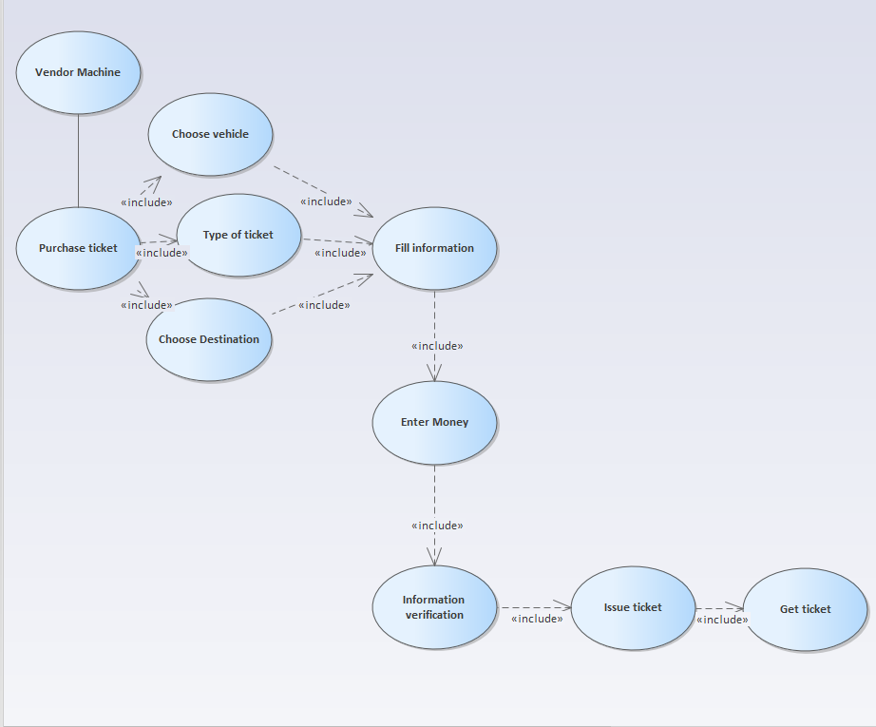

Description: customers come to the Vendor machine then start buying ticket. The screen display a menu include all type of ticket, price and the destination. Customers have to give information to the machine and enter money then they will check the information one more time. After that the ticket will be issued and customers will receive ticket then join the vehicle.

More information:

- In case, customers do not have enough money to pay for the ticket an error message will be showed on the screen. Furthermore, if customers do not pay within the specified time, the payment will be canceled.

- Customers have to make the payment again if the previous payment was refused.

1). Using credit card’s use case diagram:

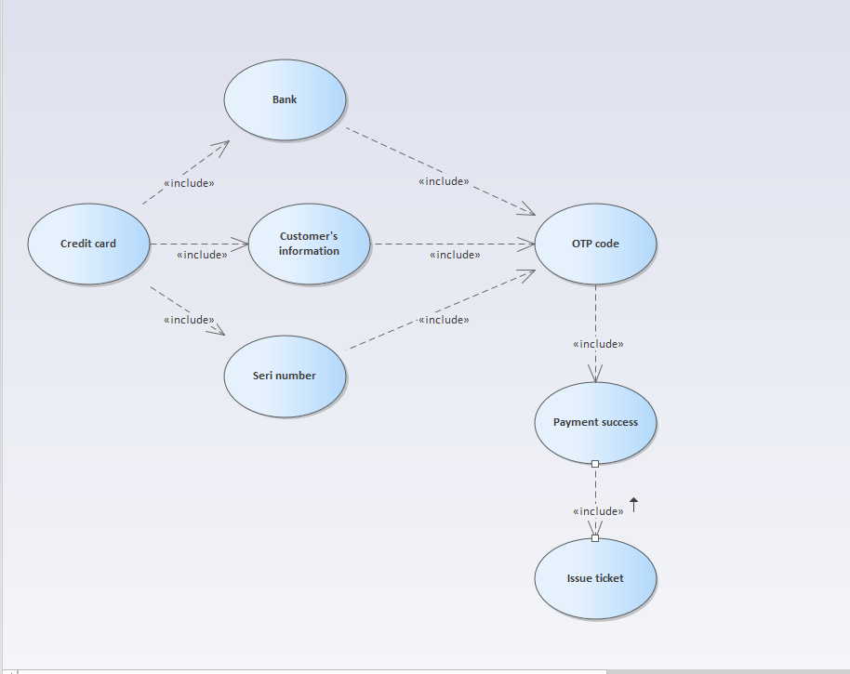

- Customers use Vendor machine to buy ticket and the payment method is using credit card. Customers choose destination and using credit card to pay for the ticket. They have to give the system all the information enough about their card. Finally, they have to enter the code to verify payment, the system will issues tickets and deduct money from user card.

- First system must be connected to online payment and users must have enough money to buy tickets. Money from users account will be deduct.

Note: if the information given is not available or, the system illustrate an error message. In addition, if the payment is not successful, the system force users to choose another payment methods. The tickets will be issued when the payment was success. Nevertheless, if the ticket is not issued, users need to call support staff.

2). Using digital wallet’s use case diagram:

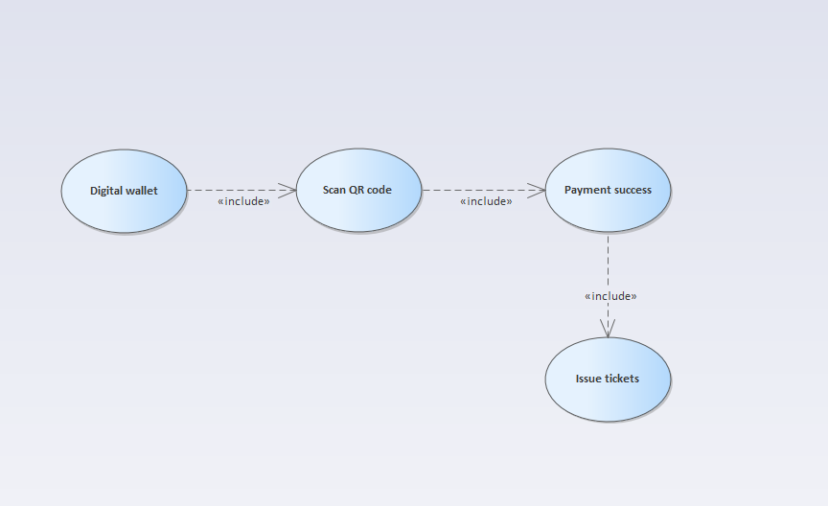

- With this method users use Digital wallet method to pay for the tickets. They will choose the destination that they want to arrive then scan the QR code to make payment. Finally, the system will verify the payment is success or not then issues tickets.

- Note: if the payment was not successful the system ask users to choose another payment method or cancel payment.